**1.Signup(connecting Accounts)**

Connect with bank page

Signup

Home

Check two checkboxes

Login

Intro page

Connect to bank

Select bank and login with your bank

Connecting plaid

Connecting success

2.**After Login:**

Cathe Home

current_balace=10000,

Estimated_spend=10500     s.shortage=500

(customer loan decision attributes)

Eligible for fund. and shows loan details

Already member

I don’t want fund

Back to user home

Already member

Proceed with basic,the user continue with the fund of 200

Upgrade to premium

If shortage is >200, user selection is basic, need to upgrade page

free membership page at first login

Check transactions,

Click Next

Transaction details(user Home)

Login

Click update

Enter additional spend amount

Check with check box if user have additional spend

yes

Selecting membership click next

Basic =200, Premium=800

no

shortage is less than 200,user selection is basic

Or

Shortage is greaterthan 200,user selection is premium

2.a **Eligible for fund showing loan details**

Page displays payment summary

Click to confirm,display confirmation

message

Give fund for user ,Click submit

Click next

Premium limt:800, basic limt=200

Planned payments=fund from user + fund from cathe

Fund from cathe=due amount - fund from user

If fund from user > due ,alert(your fund is greather than due)

If fund from cathe >limt

alert("your are eligilble to fund your bills upto limit increase you fund or upgrade")

if planned payments < due display alert

Select any one the check box with loan

If the user don’t want funding means go the user home page

Eligible for fund. and shows loan details

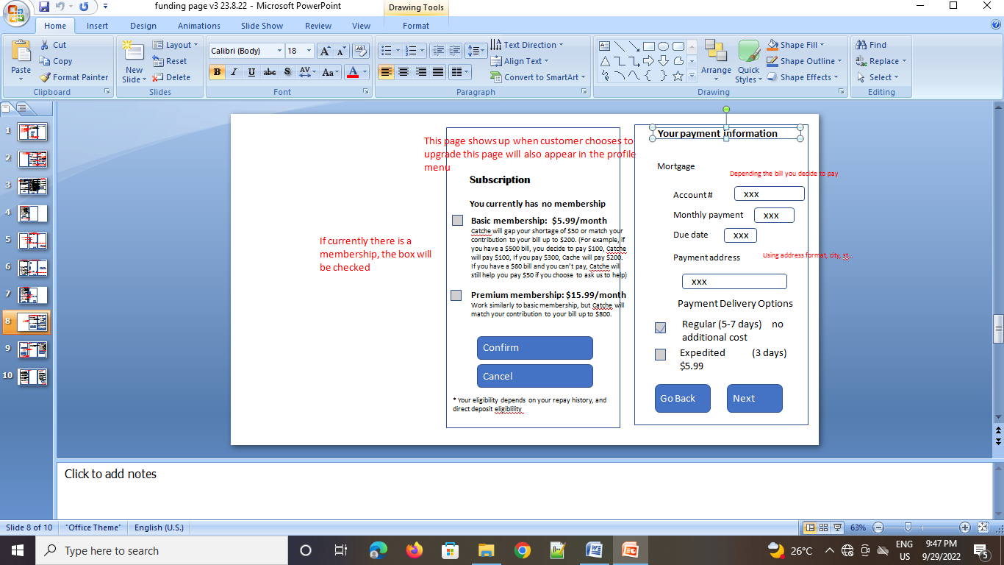

They asking this page to be inserted before payment summary